**MAE 560 Applied CFD, Fall 2023**

**Project 1: Internal Flow with Thermodynamics**

Pradnesh Laxman Mhatre

ASU ID – 1226479399

**Task 1: Internal flow with thermal convection (Buoyancy effect)**

A simple water tower which has a main cylindrical tank and two cylindrical side pipes for the inlet and outlet. All solid surfaces of the system are thermally insulated, except that the temperature at the bottom plate of the main cylinder is externally maintained at a constant 50°C. The temperature of the water entering the inlet is fixed at 20°C. At t = 0, the whole tank, including the side pipes, is filled with water at 50°C.

**Task 1a: Transient solution with Earth gravity**

Here g = -9.81

* Initializing the system at t = o with gauge pressure and uniform temperature of T=50°C
* Initialize turbulence kinetic energy (k) = 0.01 m2s-2
* Specific dissipation rate (omega) = 0.01 s-1
* Fromula for avg. temperature TAVE is

**D1**: A plot of the mesh along the plane of symmetry, and a statement indicating the values of

operating temperature, operating density, and thermal expansion coefficient for the Boussinesq setting, and the time step size and maximum number of iteration per step for the transient simulation.

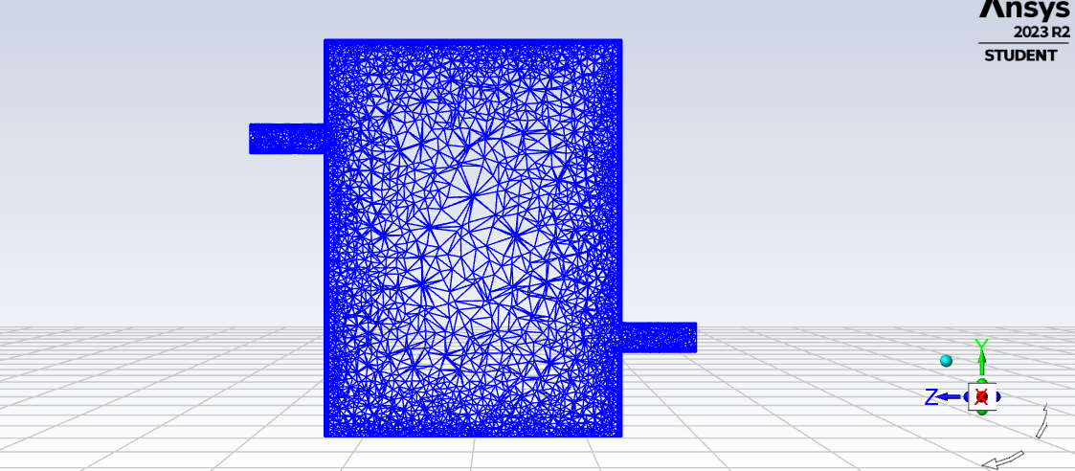

Figure 1: Deliverable 1 Mesh

**D2**: Contour plots of the y-velocity (not to be confused with velocity magnitude) and temperature in the plane of symmetry for the solution at t = 1 minute.

Figure 2: D2 Temperature

Figure 3: D2 Y-velocity

**D3:** Contour plots of the y-velocity and temperature in the plane of symmetry for the solution at t = 5 minutes**.**

Figure 4: D3 Static Temperature

Figure 5: D3 Y-Velocity

**Task 1b: Transient Solution with Moon gravity**

Here we are changing the gravity from Earth to Moon in y-direction from -9.81 to -1.62 ms-2

**D5:** Contour plots of the y-velocity and temperature in the plane of symmetry for the solution at t = 1 minute.

Figure 6: D5 Static Temperature in Moon's Gravity

Figure 7: D5 Y-Velocity in Moon's Gravity

**Task 2: Internal Flow with heat source**

In practice, water heaters for household applications have very different designs. One of which is to run water through a coiled pipe with heated wall. This allows water to heat up quickly within limited space.

Consider a helical pipe with its center traced by the equation of a helical curve,

X(τ) = R cos(τ)

Y(τ) = R sin(τ)

Z(τ) = C τ

where τ is a dummy parameter to help tracing the curve. For this task, the curve is traced from τ = 0 to τ = 12 π (radian), with R = 0.3 m and C = 0.15/(2π) m.

**Task 2a: Flow with heated wall**

For this task we take water as the fluid for the system. Let the inlet temperature be 300°K and the uniform energy input of 1000 Wm-2 at the wall.

**D6:** The values of ΔT for the 4 cases from the steady solution produced by Fluent, compared with the corresponding “hand calculation” (∆𝑇)𝐻. [We do not expect a very close match, since Eq. (6) is derived by assuming that the pipe is straight and the flow is uniform, etc.] This should be presented as a table. In addition, make a plot of “ΔT vs. inlet velocity” and “(∆𝑇)𝐻 vs. inlet velocity”. Collect the two curves in the same plot.

|  |  |  |
| --- | --- | --- |
| **Hand Calculations** | **Temperature ΔT** | **Velocity** |
| **13.58** | **9.9079** | **0.01** |
| **6.79** | **5.0988** | **0.02** |
| **3.4** | **2.6141** | **0.04** |
| **1.68** | **1.2883** | **0.08** |

Figure 8: D6 (∆𝑇) vs inlet velocity and (∆𝑇)𝐻 vs inlet velocity

**D7:** For the case with inlet velocity = 0.01 m/s only, a line plot of Tout as a function of the number of iterations.

Figure 9: T(out) line plot at inlet velocity = 0.01 m/s

**D8:** For the case with inlet velocity = 0.01 m/s only, contour plots of temperature and velocity magnitude over the circular opening of outlet. Please indicate the inner and outer edges of the pipe in the contour plots. In addition, a contour plot of temperature for the outer boundary of the whole system (the “skin” of the helix), in isometric view.

OUTER SIDE

INNER SIDE

Figure 10: D8 Static Temperature

OUTER SIDE

INNER SIDE

Figure 11: D8 Velocity magnitude

Figure 12: Static Temperature

**Task 2b: Viscous heating**

Now We use glycerin instead of water as the fluid in the pipe. Setting all physical parameters for glycerin to constant using the values from Fluent database.

**D9:** The values of ΔT for the 4 cases, where ΔT = Tout – Tin is the difference between outlet and inlet temperature at steady state. In addition, make a plot of ΔT vs. inlet velocity.

Figure 13: ΔT vs inlet velocity

**D 10:** You may notice that in Task 2a ΔT decreases with inlet velocity, while in Task 2b ΔT increases with inlet velocity. Briefly explain why

In the second scenario, it's evident that even though there's an identical temperature difference at the beginning, the presence of fluid friction causes an escalation in viscous heating as velocity rises. When the velocity goes from 1 m/s to 2 m/s, the substantial rate of velocity change boosts kinetic energy, consequently leading to an augmentation in internal energy.